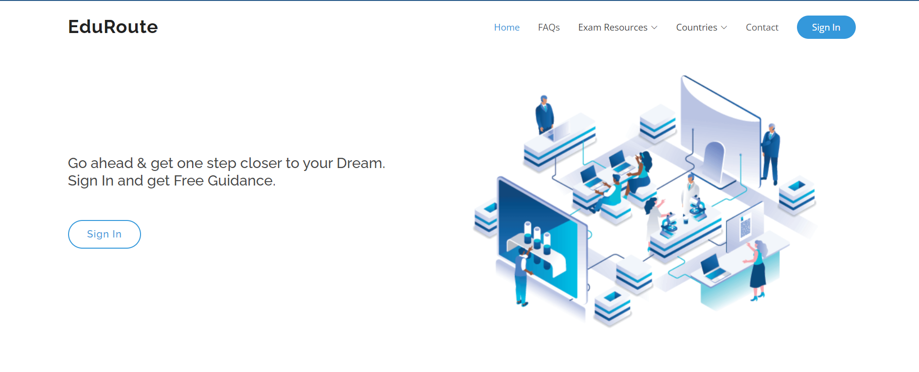

**Home Page:** with nav bar including Options like (All the pages include navbar)

**FAQs**,

**Exam resources with drop down**: Indian & Foreign Exams,

**Countries option with drop down**: India, USA, Australia, Canada,

**Contact Page,**

**Sign in:** In the right corner & center of the page

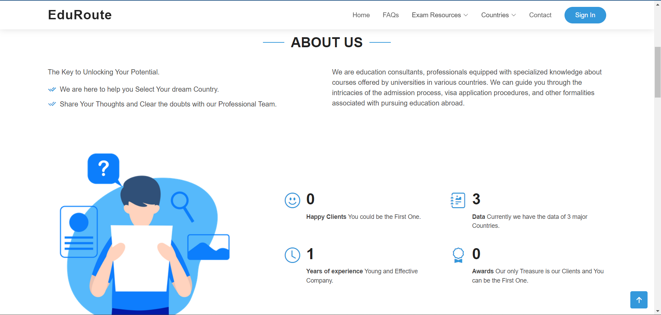

**About Us page:**

Details about what are company provides: also no. of clients, major data, experience, awards.

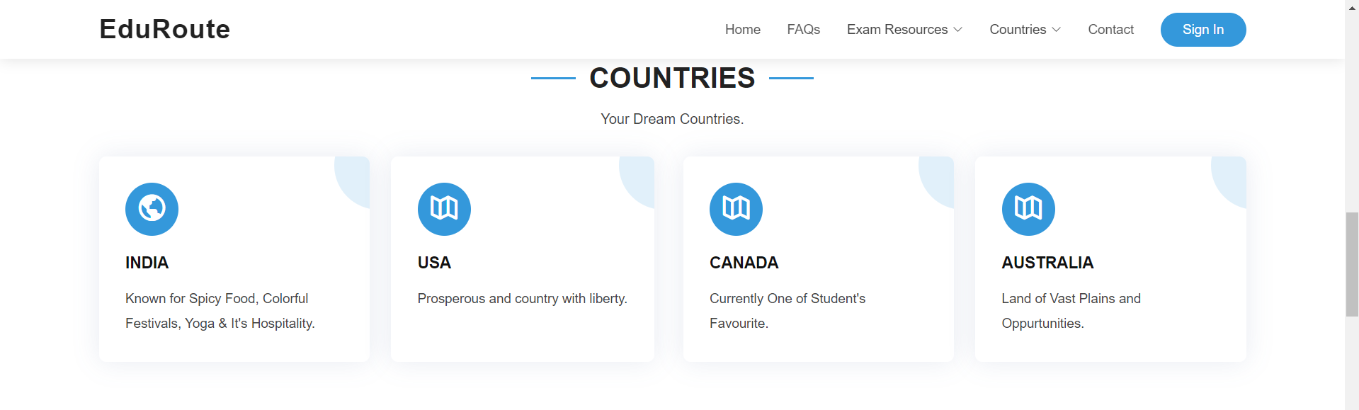

**Options to gat into countries page:**

Options: INDIA, Australia, USA, Canada

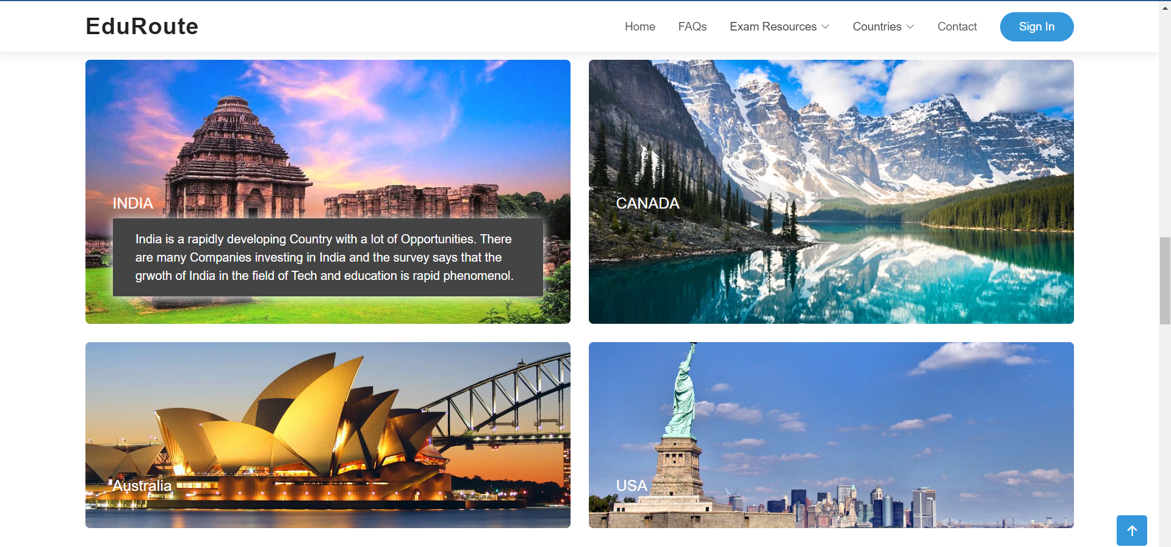

**Page for interesting facts about all the countries**

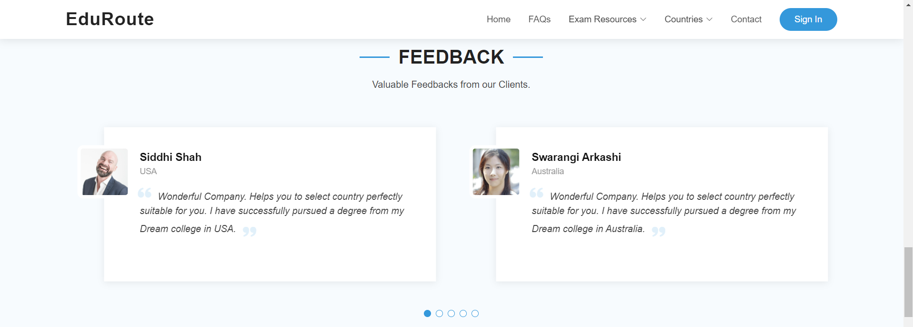

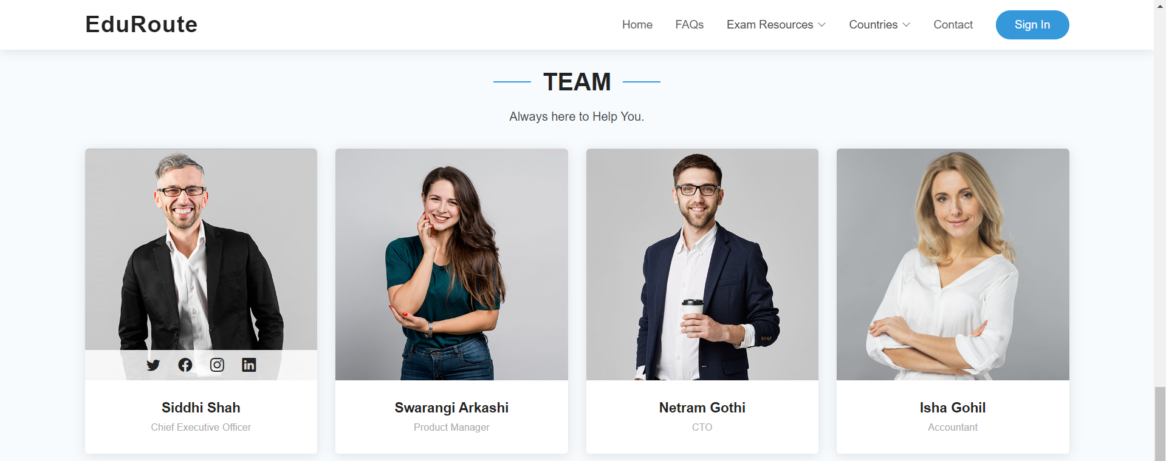

**Team and feedback page**

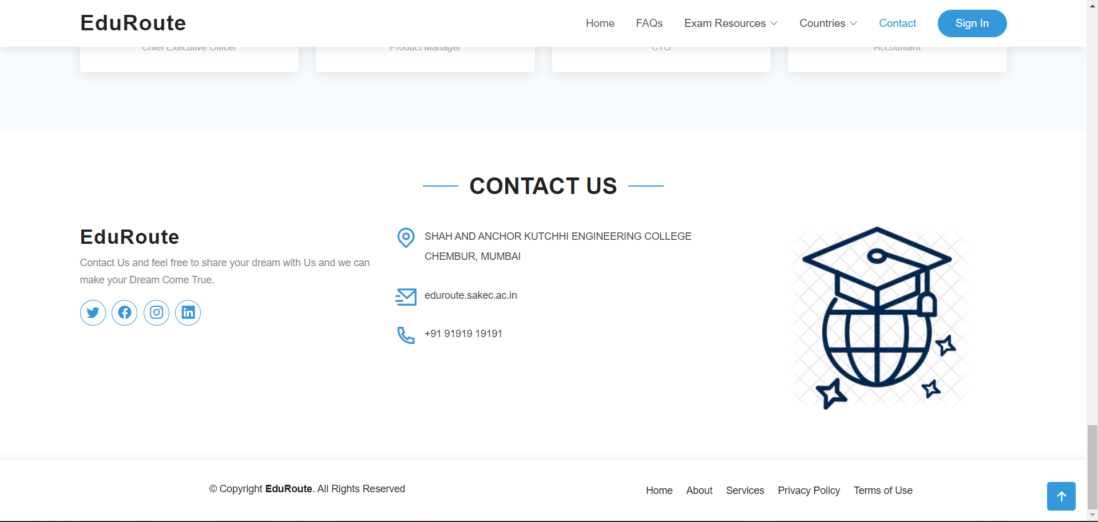

**Contact page with social media links**

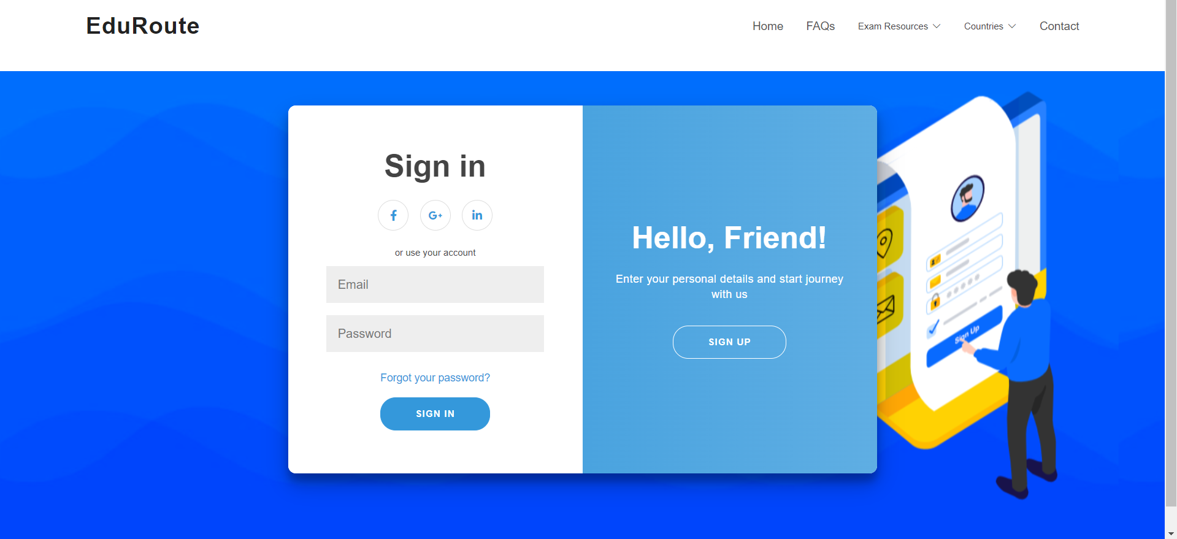

**Sign Up & Sign In page**

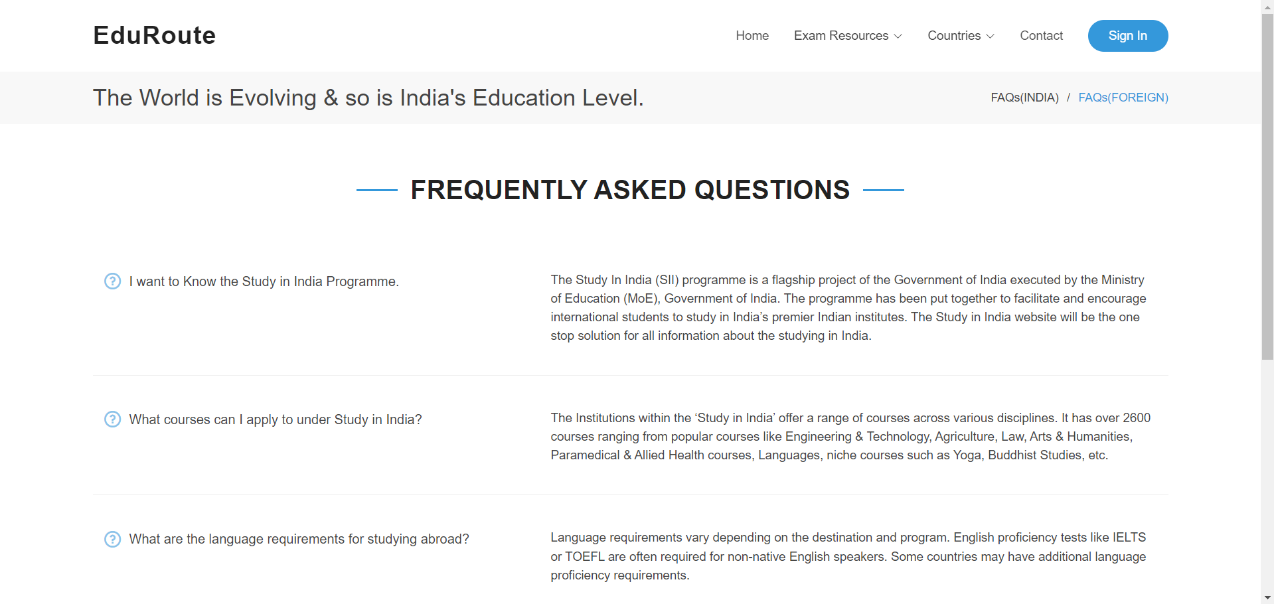

**Frequently asked Question page:** For both India and Foreign Countries

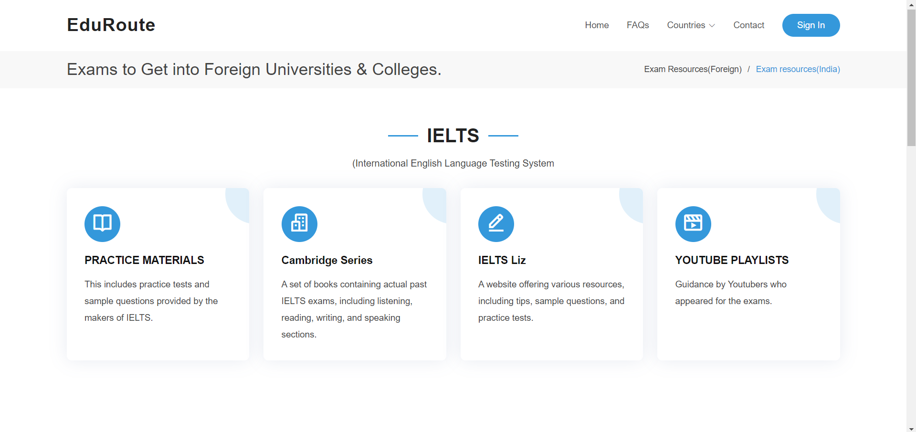

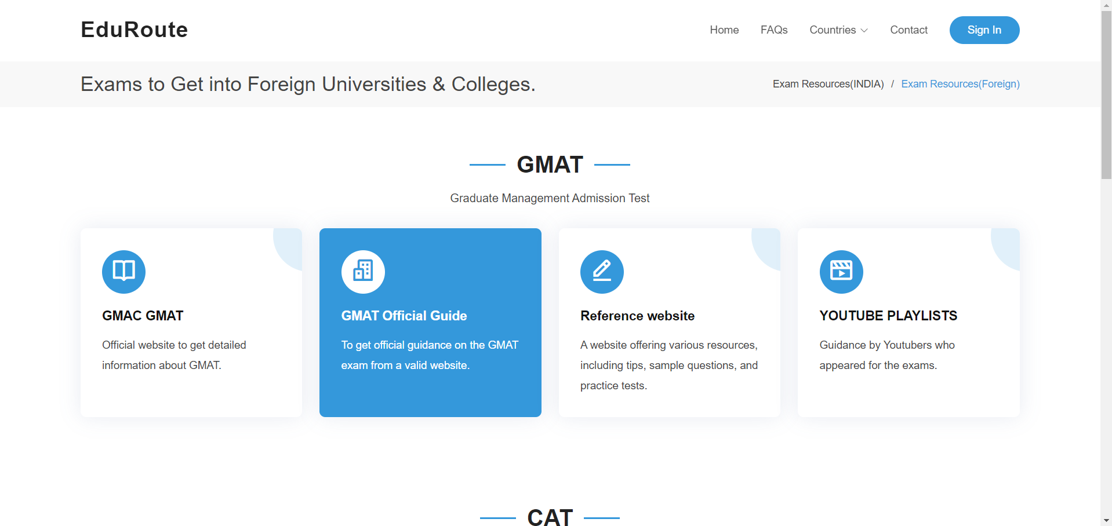

**Exam resources for both Foreign countries and India**

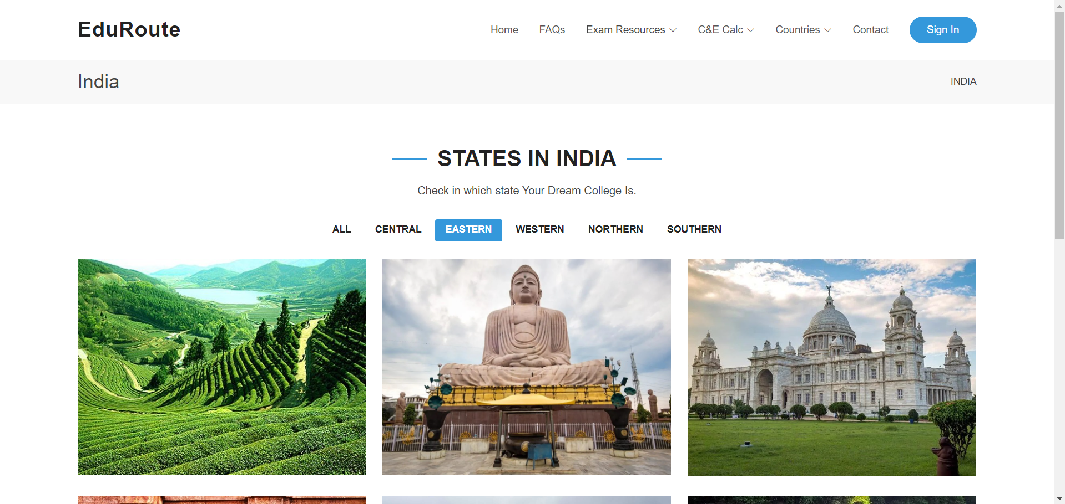

**Country specific pages:**

With filter for states divided on the basis of direction situtated in.

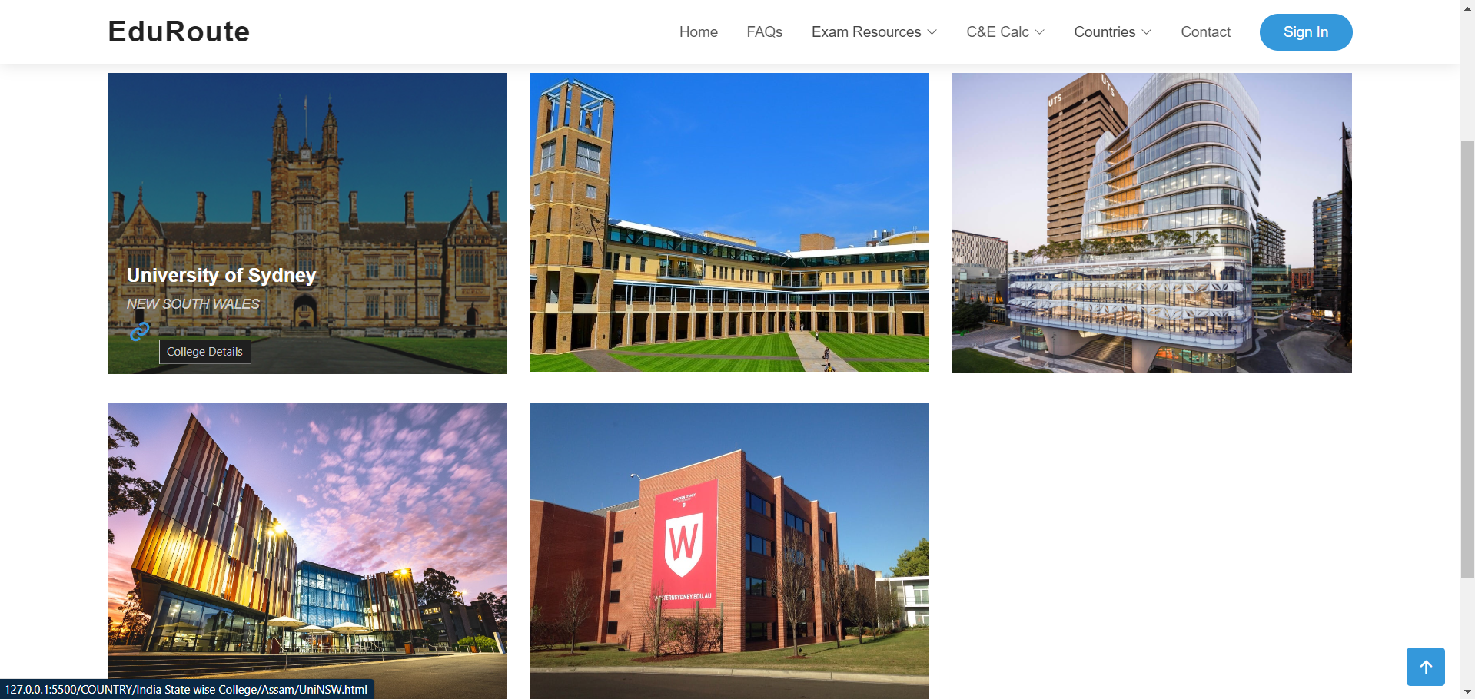

**After selecting the state you get to the college specific page:**

Each state currently includes the data of 5 colleges or universities.

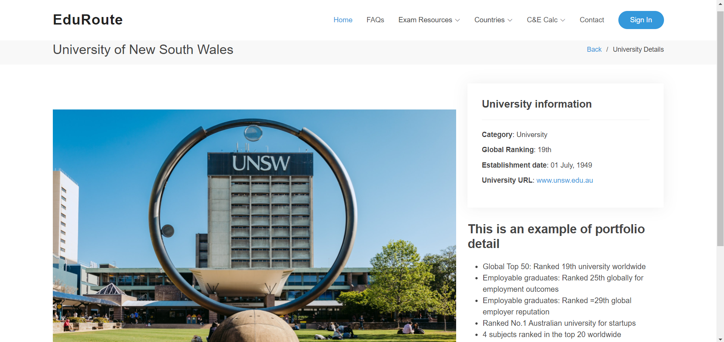

**After selecting the college you get to the college detail page:**

This pages include the clg related photos, ranking, establishment year, as well as the university or college website. It also includes the detail we gathered on the basis of our research.

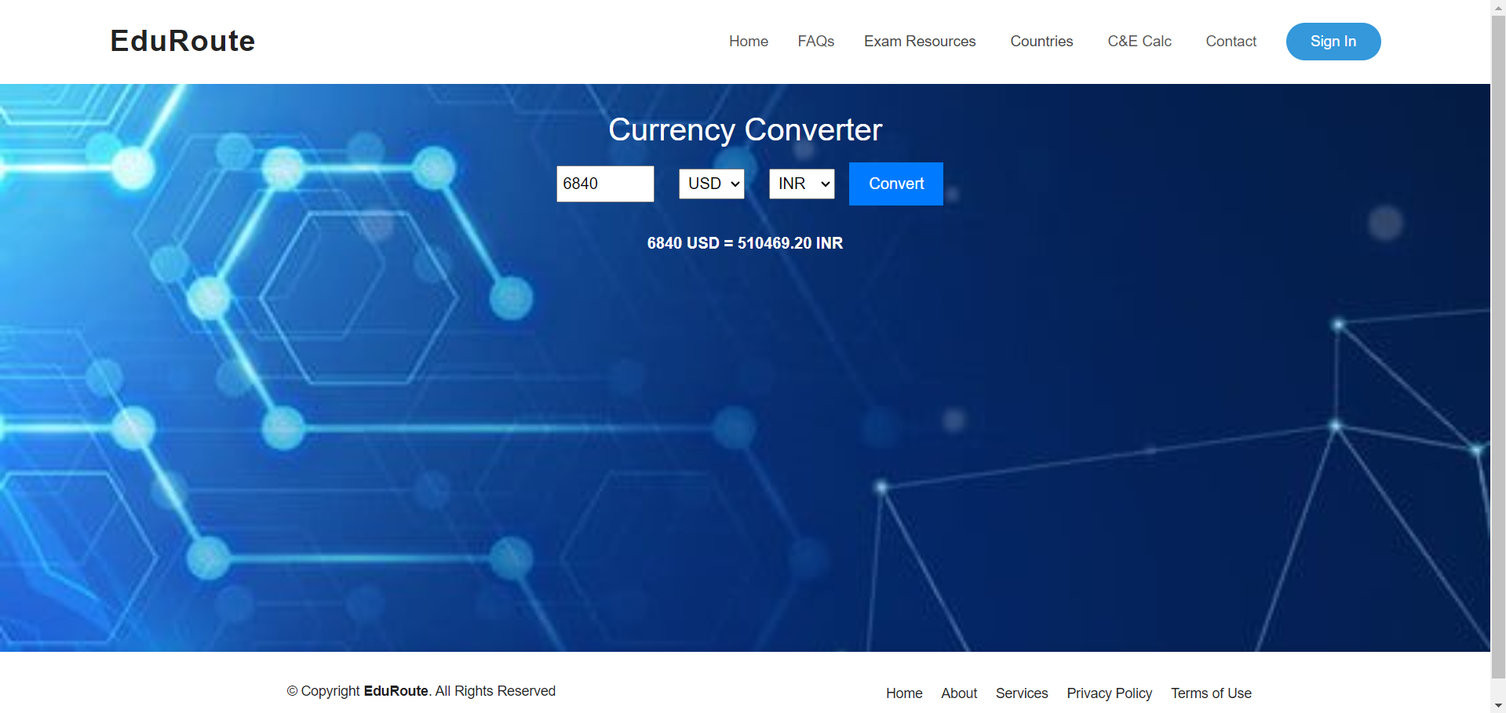

**Currency Calculator page:**

To convert the currency of one country to another: options Indian rupees, Australian dollar, Canadian dollar, American dollar

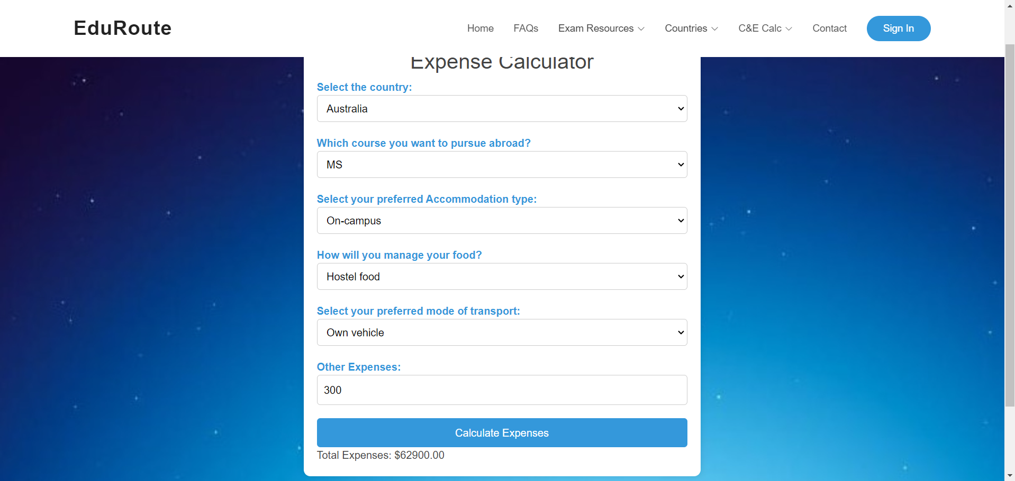

**Expense calculator to get a rough idea about expenses:**

After the calculation can be converted to your currency using currency calculator.